Cristian Silega

198:334 Digital Imaging and Multimedia

Assignment 1- Multimedia Digitization

[Q1 10 pts] Suppose you have an 8-bit A/D converter that has a full-scale input range of 2V to 6V. When a particular voltage is applied, the computer records the hex number B3. Assuming a perfect calibration, answer the following questions:

- What output voltage does this value correspond to?

- What is the digitization (quantization) error in the voltage?

- By how much percent would this error change if 12 bits were used to approximate the output instead of 8 bits?

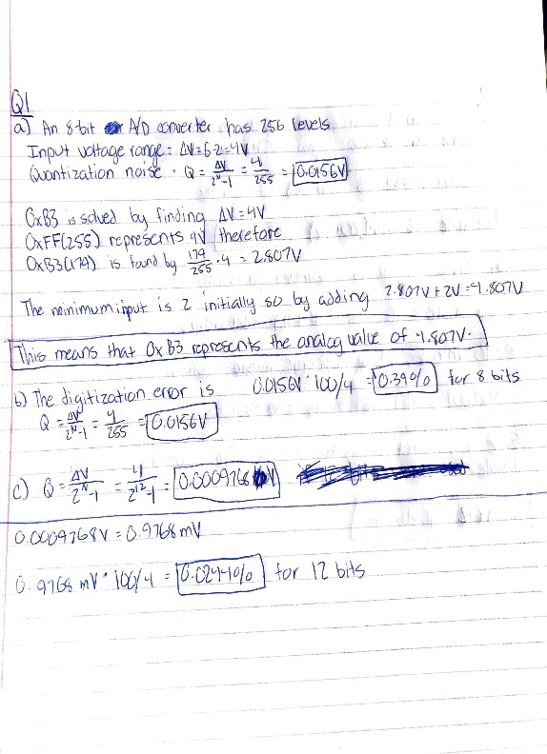

[Q2 10 pts] The bandwidth of a speech signal is from 50 Hz through to 10 kHz and that of a music signal is from 15 Hz through to 20 kHz. You want to digitize these signals using the Nyquist criterion.

- What is the bit rate produced for the speech signal if 12 bits are used per sample?

- Perform the same for the music signal when 16 bits per sample are used.

- How many megabytes of storage do you need for 10 minutes of stereophonic music?



[Q3 10 pts] The high-frequency limit of human hearing extends to approximately 20 kHz, but studies have shown that intelligible speech requires frequencies only up to 4 kHz.

- Justify why the sampling rate for an audio compact disc (CD) is 44.1 kHz. What is the Nyquist rate for reliable speech communications?

- Why do you think people sound different on the phone than in person?

- Suppose intelligible speech requires 7 bits per sample. If the phone system is designed to precisely meet the requirements for speech (which is the case), what is the maximum bit rate allowable over telephone lines?

- CDs use 16 bits per sample. What is the bit rate of music coming off a CD? Is a modem connection fast enough to support streamed CD quality audio?

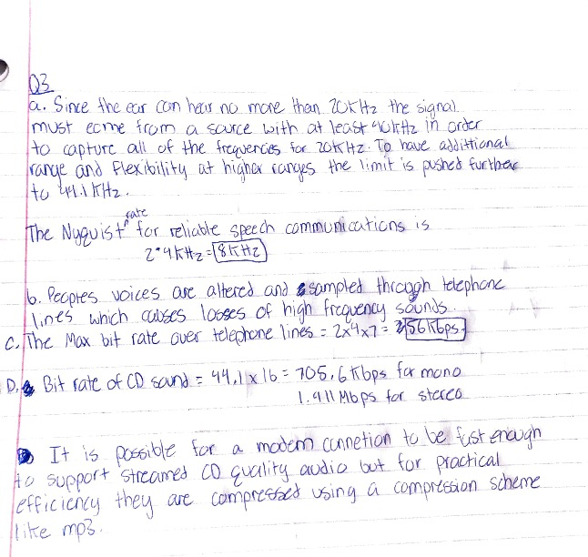

[Q4- 10pts] Determine the number of bytes necessary to store an uncompressed RGB color image of size 640x480 pixels using 8,10,12, and 14 bits per color channel.

[Q5 – 10pts + 10 extra credit] This question will be a part of a multistage assignment with the goal of collecting statistics about images and video on the Internet. In this question we are trying to collect data about how many images and videos are available on the Internet. For this task, your job is to do some research to collect 5 to 10 data points about the number of images and/or videos uploaded to a given site or sites. For example, a data point might be: “in 2011 6 Billion images were uploaded every month to Facebook according to source x” or “in 2011, 48 hours of video are uploaded every minute according to source y”. The data points can also be cumulative, for example “in 2011 the total number of images in Facebook reached x Billion images” The expected information in a data point is: - The site name (Facebook, Flicker, YouTube, Instagram,… )

- The year

- Number of images or videos uploaded, or size of the image/video data (e.g. x terabyte)

- The unit time (per minute, per day, per month,…), or cumulative.

- The source for this information (e.g. URL, publication, etc.)

You need to collect 5 to 10 data points. Your grade will depend on the number of data points you collect, and the rareness/uniqueness of these data points. For example, if many of you get the same data point, your grade for this data point will be less than if you come up with a data point that nobody else got. So, you need to be creative in your searches online to explore data about different sites.

1. As of 2021, **95 million photos** and videos are shared on Instagram per day according to <https://www.wordstream.com/blog/ws/2017/04/20/instagram-statistics#:~:text=8.,shared%20on%20Instagram%20per%20day>.
2. As of 2019, **720,000 hours** of video uploaded every day to YouTube according to <https://www.oberlo.com/blog/youtube-statistics#:~:text=500%20hours%20of%20video%20are,uploaded%20every%20day%20to%20YouTube>.
3. As of 2020, approximately 28 billion **approximately 28 billion photos** and videos are uploaded to google every week according to <https://en.wikipedia.org/wiki/Google_Photos>
4. As of 2019, More than 250 billion photos have been uploaded to Facebook according to <https://www.brandwatch.com/blog/facebook-statistics/#:~:text=Users%20generate%204%20million%20likes,350%20million%20photos%20per%20day>.
5. As of 2019, On average **350 million photos** are uploaded daily to Facebook according to <https://blog.wishpond.com/post/115675435109/40-up-to-date-facebook-facts-and-stats#:~:text=On%20average%20350%20million%20photos%20are%20uploaded%20daily%20to%20Facebook>.
6. As of 2020, **3**.**2 billion images** are shared online daily according to <https://theconversation.com/3-2-billion-images-and-720-000-hours-of-video-are-shared-online-daily-can-you-sort-real-from-fake-148630>
7. As of 2020, **720,000 hours of video** are shared online daily according to <https://theconversation.com/3-2-billion-images-and-720-000-hours-of-video-are-shared-online-daily-can-you-sort-real-from-fake-148630>
8. As of January 2021, **1074 photos** are uploaded on Instagram every second according to <https://www.omnicoreagency.com/instagram-statistics/#:~:text=More%20than%2050%20billion%20photos,use%20explore%20page%20every%20month>.